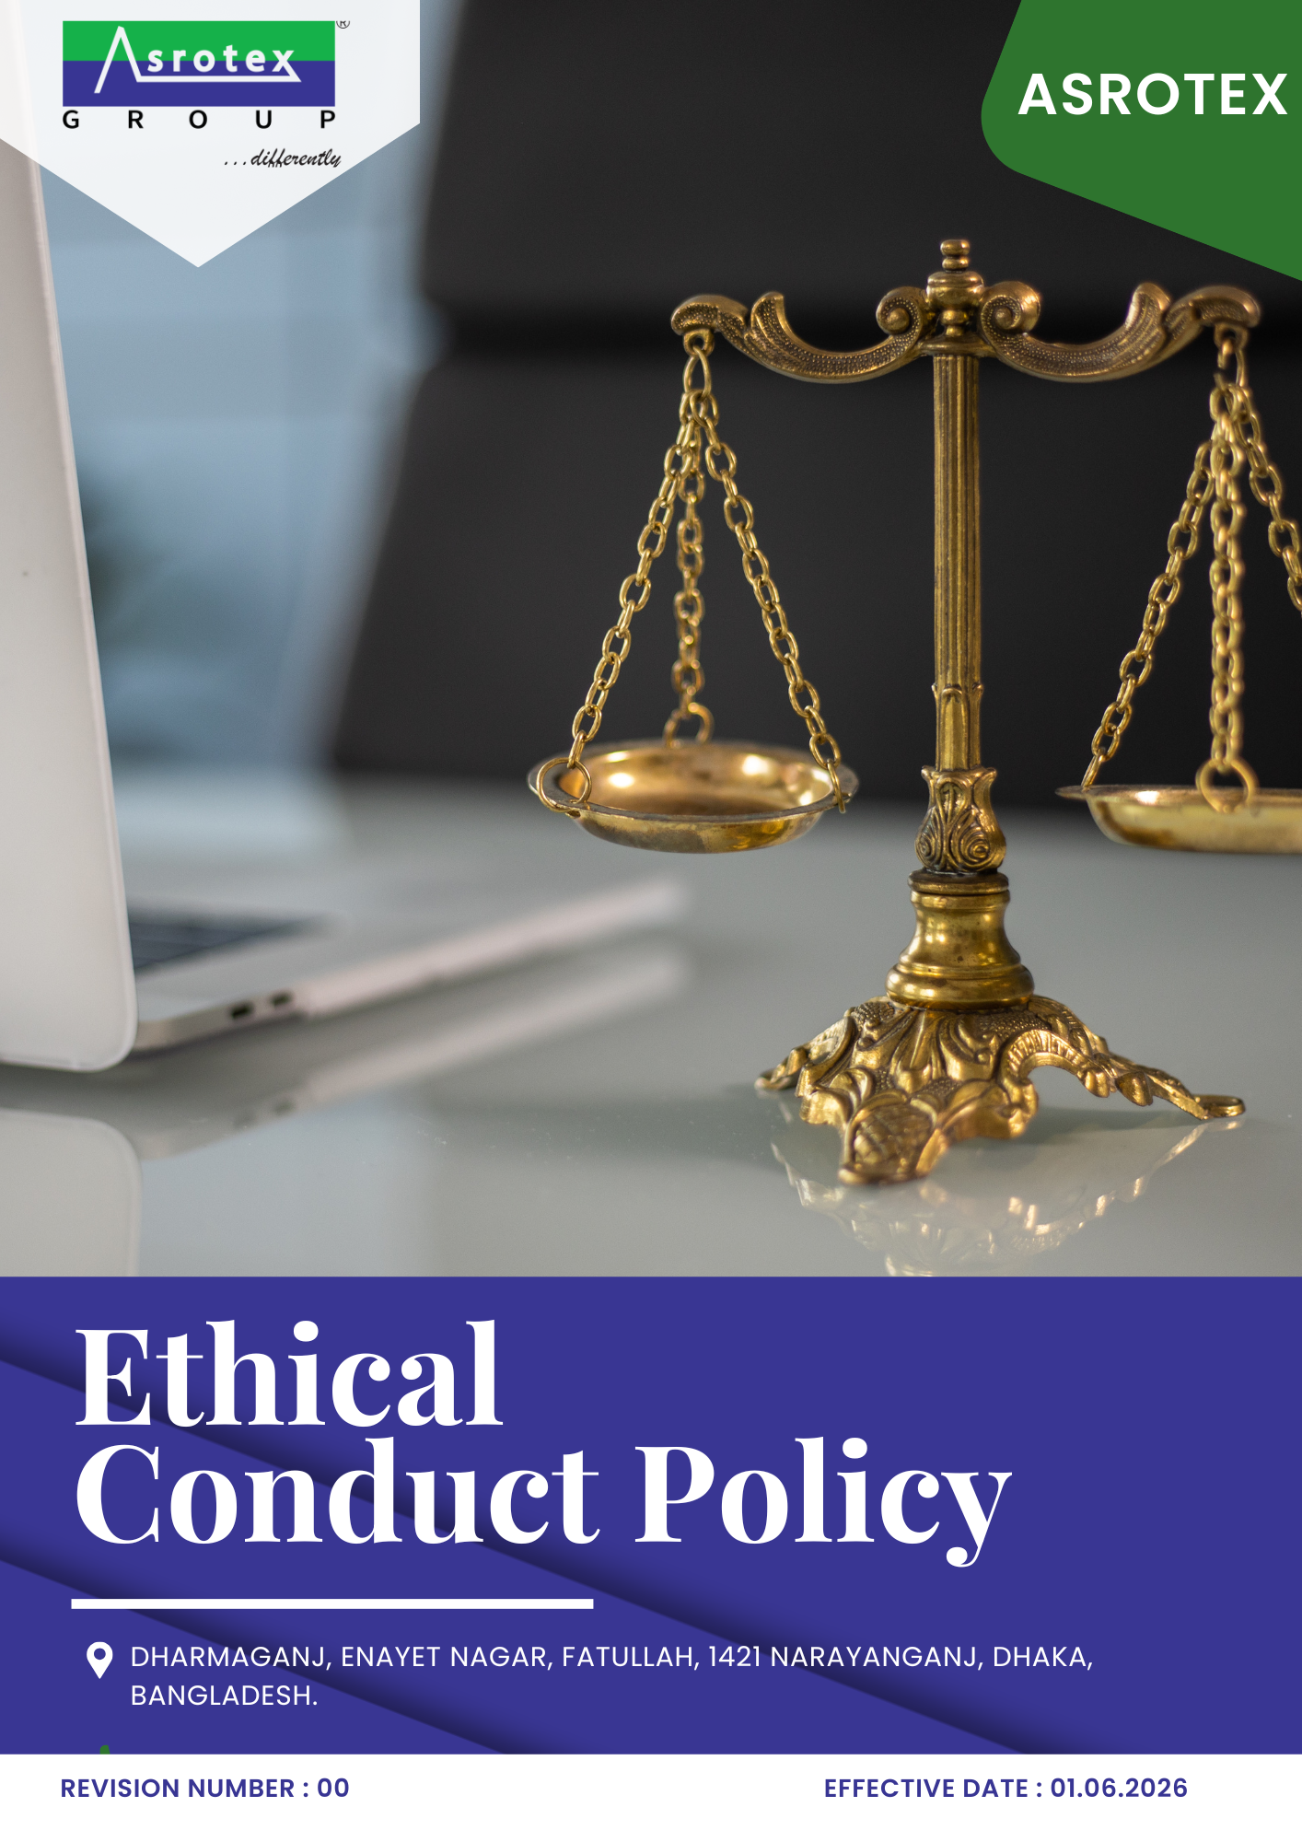

TABLE OF CONTENTS
Asrotex— Ethical Conduct Policy

Contents
01 Preface 3
02 Purpose 3
03 Scope 3
04 Ethical Conduct Commitments 3
05 Roles & Responsibilities 4
06 Action Areas 4
07 Ethical Decision-Making & Business Conduct 7
08 Reporting, Whistleblower Protection & Case Management 8
09 Policy Compliance & Disciplinary Actions 9
10 Ethical Performance, Monitoring & Reporting 9
11 Review Mechanism & Continual Improvement 10
Annexure A – United Nations Sustainable Development Goals (UNSDGs) 11
Employee Acknowledgment 12

01 Preface
Asrotex is committed to conducting its business with the highest standards of integrity, honesty, fairness, and accountability. We believe that ethical conduct is fundamental to sustainable business success and serves as the foundation for building trust with employees, customers, suppliers, business partners, shareholders, and the communities in which we operate.
This Ethical Conduct Policy establishes the framework for promoting ethical behaviour, responsible decision-making, and transparent business practices across all aspects of the Company's operations. Through strong governance, effective internal controls, employee awareness, and continual improvement, Asrotex is committed to preventing unethical practices, ensuring compliance with applicable legal and regulatory requirements, and fostering a culture of integrity that supports long-term sustainable business growth.

02 Purpose
The purpose of this Ethical Conduct Policy is to establish a framework for promoting integrity, ethical behaviour, and responsible business practices across Asrotex's operations. The policy aims to prevent corruption, fraud, conflicts of interest, and other unethical practices, ensure compliance with applicable legal and regulatory requirements, strengthen stakeholder trust, and drive continual improvement in ethical governance and corporate conduct.

03 Scope
Sr. No. | Site | Address
1 | Asrotex | Dharmaganj, Enayet Nagar, Fatullah, 1421 Narayanganj, Dhaka, Bangladesh.
This Ethical Conduct Policy applies to all operations and business activities carried out at the following operational location of Asrotex :

This policy applies to all employees, directors, contract workers, trainees, consultants, contractors, suppliers, service providers, agents, and other business partners acting on behalf of Asrotex. It covers all business activities, decisions, and interactions undertaken by or on behalf of the Company and establishes the framework for promoting ethical behaviour, responsible business conduct, regulatory compliance, and integrity across all operations and business relationships.

04 Ethical Conduct Commitments
Asrotex is committed to:
- Conducting all business activities with honesty, integrity, fairness, transparency, and accountability.
- Prohibiting all forms of bribery, corruption, fraud, money laundering, conflicts of interest, anti-competitive practices, and other unethical business conduct.
- Promoting a culture of ethical decision-making, responsible leadership, and compliance with applicable legal, regulatory, and internationally recognized ethical standards.
- Encouraging employees, suppliers, contractors, and business partners to uphold the highest standards of professional conduct and ethical behaviour.
- Protecting confidential information, Company assets, and stakeholder interests through responsible information management and sound governance practices.
- Promoting a speak-up culture by providing secure reporting channels and protecting individuals who report concerns in good faith from retaliation.
- Monitoring ethical performance and driving continual improvement through awareness, training, internal controls, audits, and effective governance practices.
Unless otherwise specified, 2023 has been established as the baseline year for measuring ethical conduct performance and tracking progress against the objectives and targets defined in this policy.

05 Roles & Responsibilities
- Compliance Officer: Owns the implementation of this policy — overseeing anti-corruption, fraud prevention, conflict-of-interest, anti-money-laundering, and information-management practices, and acting as the escalation point for serious concerns.
- Senior Management: Sets the tone from the top by embedding ethical principles into company strategy, allocating the resources needed to act on them, and holding the organisation accountable for results.
- HR Manager: Delivers employee training and awareness on ethical conduct, and ensures new hires understand the standards expected of them from day one.
- Department Heads: Ensure policy requirements are applied within their teams’ daily operations, and act as a first point of contact for ethical questions on the floor.
- Internal Audit Team: Conducts periodic audits and assessments to monitor compliance, identify risk areas, and recommend corrective action where gaps appear.
- IT Manager: Safeguards sensitive data and oversees the technical measures that support responsible information management.
- Employees and Workers: Follow the policy, complete required training, and report suspected violations through the appropriate channel rather than staying silent.
- Suppliers and Business Partners: Align their own practices with Asrotex’s ethical standards, comply with applicable law, and participate in audits and assessments as required.

06 Action Areas
1 Anti-Corruption and Anti-Bribery
Objective
To prevent corruption and bribery by promoting integrity, transparency, and accountability in all business activities and relationships.
Initiatives
- Promote ethical decision-making through regular anti-corruption awareness and training programmes.
- Conduct appropriate due diligence for third parties, agents, intermediaries, and other business partners based on identified corruption risks.
- Periodically review anti-corruption controls and strengthen measures to prevent, detect, and address unethical practices.
TARGET
Ensure 100% of relevant employees complete anti-corruption and anti-bribery training annually.
Conduct anti-corruption due diligence for 100% of high-risk third parties before engagement by 2030.
2 Conflict of Interest
Objective
To ensure that business decisions are made objectively, fairly, and in the best interests of Asrotex by identifying, disclosing, and appropriately managing actual, potential, or perceived conflicts of interest.
Initiatives
- Require employees and relevant business partners to disclose actual, potential, or perceived conflicts of interest in a timely manner.
- Maintain transparent procedures for reviewing, managing, and documenting declared conflicts of interest.
- Ensure individuals with declared conflicts are removed from related decision-making processes, where appropriate.
- Promote employee awareness of conflict-of-interest requirements through regular training and communication.
TARGET
Obtain conflict of interest declarations from 100% of applicable employees annually.
Ensure 100% of newly appointed employees in applicable roles complete conflict of interest awareness training within three months of joining.
3 Fraud Prevention
Objective
To prevent, detect, and address fraudulent activities by strengthening internal controls, promoting ethical behaviour, and ensuring accountability across all business operations.
Initiatives
- Establish and maintain effective internal controls to prevent and detect fraud.
- Promote employee awareness of fraud risks through regular training and communication.
- Investigate reported fraud incidents promptly and implement appropriate corrective actions.
- Periodically review fraud prevention measures to strengthen governance and operational integrity.
TARGET
Conduct fraud risk assessment for all high-risk business functions by 2030.
Maintain zero material fraud incidents resulting in financial or reputational loss annually.
Provide fraud awareness training to 100% of applicable employees annually.
4 Anti-Money Laundering
Objective
To prevent money laundering and other financial crimes by implementing effective due diligence, monitoring, and reporting practices.
Initiatives
- Conduct appropriate customer and third-party due diligence based on identified AML risks.
- Monitor business transactions and relationships for unusual or suspicious activities.
- Promote employee awareness of AML obligations and reporting requirements.
- Maintain procedures for reporting suspicious activities in accordance with applicable legal requirements.
TARGET
Conduct AML due diligence for 100% of identified high-risk business relationships by 2030.
Ensure 100% of finance-function employees complete anti-money-laundering training annually
Review 100% AML controls annually to ensure continued effectiveness.
5 Anti-Competitive Practices
Objective
To promote fair competition by conducting business honestly, transparently, and in compliance with applicable competition laws and regulations.
Initiatives
- Prohibit anti-competitive practices such as price-fixing, bid-rigging, market allocation, and abuse of market position.
- Promote fair and transparent procurement, sales, and commercial practices.
- Provide awareness programmes on competition law and ethical business conduct.
- Periodically review business practices to identify and address competition law risks.
TARGET
Ensure 100% of procurement and sales personnel complete competition-law training, and maintain zero substantiated anti-competitive practice findings, by 2030.
6 Responsible Information Management
Objective
To protect the confidentiality, integrity, and availability of business information through responsible information management and secure data handling practices.
Initiatives
- Protect confidential business information and personal data through appropriate administrative and technical controls.
- Restrict access to sensitive information based on business needs and authorized responsibilities.
- Promote employee awareness of information security and data privacy responsibilities.
- Periodically review information management practices to strengthen data protection and cybersecurity.
TARGET
Ensure 100% of critical information assets are protected through appropriate access controls, backup, and recovery measures by year 2030.
Maintain zero major data-breach incidents, annually.
Complete information security risk assessments covering 100% of critical information systems annually.

07 Ethical Decision-Making & Business Conduct
Asrotex expects all employees and persons acting on its behalf to exercise sound judgment and uphold the highest standards of integrity when making business decisions. Where ethical dilemmas arise, individuals are expected to act in accordance with this Policy, applicable legal requirements, and the Company's values.
When making decisions, employees should consider whether their actions:
- Comply with applicable laws, regulations, and Company policies.
- Reflect honesty, integrity, fairness, and transparency.
- Protect the interests and reputation of Asrotex and its stakeholders.
- Avoid actual, potential, or perceived conflicts of interest.
- Can be openly explained and appropriately documented.
- Would withstand internal review or external scrutiny.

Examples of Expected Ethical Behaviour

Situation | Expected Behaviour
A supplier offers an expensive gift before a procurement decision. | Politely decline the gift, disclose the offer if required, and continue the procurement process objectively in accordance with Company procedures.
An employee discovers inaccurate financial or operational records. | Report the concern promptly through the established reporting channels and cooperate with any investigation.
An employee has a personal relationship with a supplier participating in a procurement process. | Disclose the relationship immediately and withdraw from the related decision-making process.
Confidential customer or Company information is requested by an unauthorized person. | Do not disclose the information and report the request to the appropriate authority within the Company.
An employee suspects bribery, fraud, or another ethical violation. | Report the concern in good faith through the Company's whistleblower or reporting mechanism without fear of retaliation.
A business opportunity appears to conflict with applicable laws or Company policies. | Seek guidance from the designated manager or Compliance Officer before proceeding.
Employees are encouraged to seek guidance whenever they are uncertain about the ethical implications of a decision. When in doubt, they should consult their manager, the designated Ethics Representative, or use the Company's established reporting channels before taking action.

08 Reporting, Whistleblower Protection & Case Management
Asrotex is committed to maintaining a culture where employees and other stakeholders can report suspected unethical conduct, legal violations, or breaches of this Policy without fear of retaliation. The Company encourages the prompt reporting of concerns and is committed to ensuring that all reports are handled fairly, confidentially, and in a timely manner.
The Company shall:
- Provide accessible and confidential reporting channels for employees, suppliers, contractors, and other stakeholders to raise ethical concerns in good faith.
- Protect individuals who report concerns or participate in investigations from retaliation, discrimination, or any other adverse action.
- Ensure all reported concerns are acknowledged, assessed, investigated, and resolved through a fair, impartial, and documented process.
- Maintain the confidentiality of reported information and limit disclosure to individuals involved in the investigation process, except where disclosure is required by law.
- Implement appropriate corrective and preventive actions where policy violations are substantiated and monitor their timely closure.
- Periodically review reported cases and investigation outcomes to identify trends, strengthen internal controls, and support continual improvement of the Company's ethical governance framework.

09 Policy Compliance & Disciplinary Actions
Compliance with this Ethical Conduct Policy is a condition of employment and an essential requirement for maintaining business relationships with Asrotex. All employees, contractors, suppliers, service providers, and other business partners are expected to comply with the principles and requirements outlined in this policy.
Where violations of this policy are identified, Asrotex shall ensure that appropriate actions are taken based on the nature, severity, and frequency of the non-compliance. The Company shall:
- Assess all reported or identified violations through a fair, impartial, and documented review process.
- Implement appropriate corrective and preventive actions to address identified non-compliance and reduce the risk of recurrence.
- Apply disciplinary measures, where warranted, in accordance with applicable Company procedures and legal requirements.
- Require suppliers, contractors, or business partners to implement corrective action plans where ethical non-compliance is identified.
- Suspend or terminate employment, contracts, or business relationships in cases of serious, repeated, or unresolved ethical violations, where appropriate.
- Maintain records of policy violations, investigations, disciplinary actions, and corrective actions to support continual improvement and accountability.
Disciplinary actions may include verbal or written warnings, retraining, suspension of duties, termination of employment or contractual relationships, legal action, or any other appropriate measure consistent with the severity of the violation and applicable legal requirements.

10 Ethical Performance, Monitoring & Reporting
Asrotex is committed to regularly monitoring and evaluating its ethical performance to ensure the effective implementation of this Policy and the achievement of its objectives and targets.
The Company shall:
- Monitor key ethical performance indicators, including ethics training, conflict of interest declarations, whistleblower reports, fraud prevention, anti-corruption compliance, ethical investigations, and corrective action implementation.
- Maintain accurate records of ethics-related activities, investigations, reported concerns, disciplinary actions, and compliance reviews, and periodically evaluate performance against established objectives and targets.
- Conduct internal assessments, compliance reviews, and periodic audits to identify ethical risks, monitor policy implementation, and implement appropriate corrective and preventive actions.
- Report ethical performance to Senior Management and other relevant stakeholders, where applicable, to support transparency, accountability, and continual improvement.
- Periodically review the effectiveness of ethics awareness programmes, internal controls, and reporting mechanisms to strengthen the Company's ethical culture and governance practices.

11 Review Mechanism & Continual Improvement
This Ethical Conduct Policy shall be reviewed biennially , or earlier if required due to changes in applicable legal or regulatory requirements, business operations, stakeholder expectations, emerging ethical risks, or other relevant factors.
Asrotex shall periodically evaluate the effectiveness of this Policy, review progress against its ethical objectives and targets, and implement necessary improvements to strengthen ethical governance, business integrity, and compliance practices. The outcomes of these reviews shall be considered when updating the Policy and supporting the Company's commitment to continual improvement.
Rev. No. | Effective From | Next Review Date
00 | 01.06.2026 | 01.06.2028
Approved By:

Annexure A – United Nations Sustainable Development Goals (UNSDGs)
Asrotex recognizes the importance of conducting business with integrity, transparency, and accountability. The commitments, objectives, and initiatives outlined in this Policy contribute to the following United Nations Sustainable Development Goals (UNSDGs).:
UN SDG | Key Focus Area | Relevant Policy Sections
SDG 8 – Decent Work and Economic Growth | Ethical business practices, responsible corporate governance, and fair competition | Fair Competition & Anti-Competitive Practices; Ethical Supply Chain Management
SDG 9 – Industry, Innovation and Infrastructure | Strong governance, responsible innovation, and secure information management | Responsible Information Management
SDG 12 – Responsible Consumption and Production | Responsible procurement, ethical sourcing, and sustainable business practices | Ethical Supply Chain Management; Gifts, Hospitality & Donations
SDG 16 – Peace, Justice and Strong Institutions | Anti-corruption, fraud prevention, transparency, accountability, whistleblower protection, and ethical governance | Anti-Corruption & Anti-Bribery; Conflict of Interest; Fraud Prevention; Anti-Money Laundering (AML); Reporting, Whistleblower Protection & Case Management; Policy Compliance & Disciplinary Actions
SDG 17 – Partnerships for the Goals | Responsible business relationships and ethical collaboration across the value chain | Ethical Supply Chain Management; International Trade Compliance & Sanctions

Employee Acknowledgment
I acknowledge that I have received, read, and understood the Ethical Conduct Policy of Asrotex. I understand my responsibilities under this Policy and agree to comply with its requirements while performing my duties.
I am committed to conducting all business activities with honesty, integrity, fairness, and professionalism. I further commit to avoiding conflicts of interest, protecting confidential information, complying with applicable legal and ethical requirements, and promptly reporting any suspected unethical conduct or policy violations through the Company's established reporting channels.

Name:
Position:
Signature:
Date:

